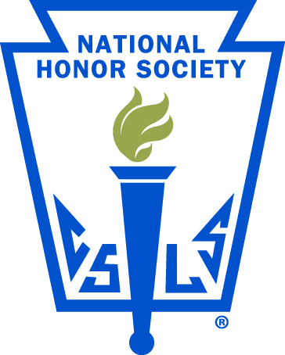

The National Honor Society is an organization that recognizes outstanding students from grades 10 through 12. It was formed in 1921 as a result of the desire of educators to promote student excellence. The James Madison Preparatory High School chapter was founded in August of 2018. The pillars of the Society are Scholarship, Character, Service, and Leadership. Chapter meetings are held bi-monthly and community services are provided through various ongoing projects.

Faculty Advisor(non voting member): Patrick White

Faculty Committee (Voting members): Alan Androski
Kaitlyn Ortega
Stephen Page
Rick Walker
James Johnson

